Experiment 1

{We will insert an introduction to the purpose of the experiment here….}

Method

The study was approved by the Indiana University Institutional Review Board.

Subjects

The subjects were 198 undergraduates from Indiana University who participated in partial fulfillment of an introductory psychology course requirement. There were 98 subjects in the repeating (REP) condition and 100 subjects in the non-repeating (NREP) condition. Subjects were randomly assigned to the conditions. All subjects had normal or corrected-to-normal vision.

Stimuli and apparatus

The stimuli used in this experiment were dot patterns generated using Posner, Goldsmith, and Welton's (1967) procedure. Each pattern consisted of 9 dots positioned in a 50 x 50 grid and connected with lines. For each individual subject, prototypes for six different categories were randomly generated. Three of the prototypes were used to generate training and transfer patterns for each of three categories; the remaining three were used to generate foils for the recognition-transfer phase.

Different training and transfer patterns of each category were generated using the statistical-distortion procedure of Posner et al. (1967). Each pattern was constructed from the prototype of its category by displacing each dot by a random distance and direction in accord with the Posner et al. procedure. Low-level, medium-level and high-level distortions were produced by displacing the individual dots, on average, 4, 6 and 7.7 Posner-levels away from their prototype. The foils used in the transfer phase were medium-level distortions of three randomly generated prototypes that were not used to generate category-training patterns.

Each individual subject was presented with a unique set of randomly generated prototypes and training and transfer patterns, with the only constraint being that the patterns were generated using the Posner et al. (1967) procedure.

We used Dell Computers to display the stimuli and control the experiment. {We should say things such as that the patterns were displayed centered on the computer screen, and provide their rough size and visual angle.}

Procedure

In both the REP and NREP conditions, a standard learning-transfer paradigm was used. In the learning phase, subjects were instructed to classify dot patterns into three categories A, B and C. On each trial a pattern was presented on the screen and the subject classified it into one of the categories by pressing a corresponding button on the computer keyboard. Following the response, the computer provided immediate feedback informing the subject of the correct category. All patterns presented during the learning phase were medium-level distortions of the prototypes. In both the REP and NREP conditions, the learning phase consisted of 15 blocks, each of which had 15 trials (225 trials total).

In the repeating (REP) condition, there were 5 unique learning patterns for each of the three categories (15 learning patterns total). The same 15 learning patterns were repeated across the 15 blocks with the order of presentation randomized within each block. In the no-repeating (NREP) condition, there were 75 unique learning patterns for each category. Within each block, 5 unique learning patterns from each category were presented in a random order. No single learning pattern was ever repeated during the learning phase.

Following the learning phase, there was a recognition-transfer phase. On each trial, a single pattern was presented and subjects were instructed to recognize whether the pattern was old (presented in the learning phase) or new (not presented in the learning phase) by pressing a labeled button on the computer keyboard (J=old, F=new). No corrective feedback was provided on any trial.

In both the REP and NREP conditions, the transfer patterns consisted of 15 old distortions that were presented in the training phase, 3 prototypes (1 per category), 15 new medium-level distortions (5 per category), and 6 foils (2 medium-level distortions generated from each of 3 prototypes not used to generate patterns in the learning phase). Each pattern was presented once in a random order for each subject for a total of 39 trials. In the REP condition, the 15 old distortions were the 15 unique patterns presented during the learning phase. In the NREP condition, the 15 old distortions were randomly sampled from the 225 learning patterns, with the constraints that no two patterns had been presented in the same learning block and that an equal number of patterns from each category was presented.

In both the learning and transfer phases, each pattern was presented centered on the computer screen and remained visible until a subject responded with a key press. In the learning phase, the corrective feedback on each trial appeared for X s below the presented pattern. All subjects were tested individually in private, sound-attenuated cubicles.

Results

Prior to conducting detailed statistical and modeling analyses, we conducted preliminary analyses to identify severe outlier subjects within each condition. In the learning phase, we computed mean proportion correct for each subject during the final 8 blocks. In the transfer phase, we computed the difference between mean proportion of old judgments on the old learning patterns and the foils. We deleted from all subsequently reported analyses the data of any subject who performed more than 2.5 standard deviations below the mean on either measure. We deleted 7 subjects from the REP condition (leaving 91 valid subjects) and 5 subjects from the NREP condition (leaving 95 valid subjects). The main pattern of results from all subsequently reported statistical and modeling analyses were essentially the same if all subjects were included in the analyses.

Learning

The proportions of correct responses across the 15 blocks in the learning phase for the REP and NREP conditions are shown in Figure 1. As can be seen, performance improved considerably across the learning blocks. More important, following the very early blocks, learning performance in the REP condition was considerably better than in the NREP condition. To confirm these observations, we conducted a 2x15 mixed-model ANOVA using learning condition (REP vs. NEP) and blocks as factors. The analysis revealed a significant effect of blocks, F(8.66,1593.89) = 140.37\* , p < .001, η2 = .433, MSe = 3.427. The main effect of learning conditions was also significant, F(1,184) = 16.26 , p < .001, η2 = .081, MSe = 4.049, as was the interaction effect between learning condition and blocks, F(8.66,1593.89) = 2.463 , p = .01, η2 = .013, MSe = 0.606 .

\*Greenhouse-Geisser correction applied for violation of the sphericity assumption.

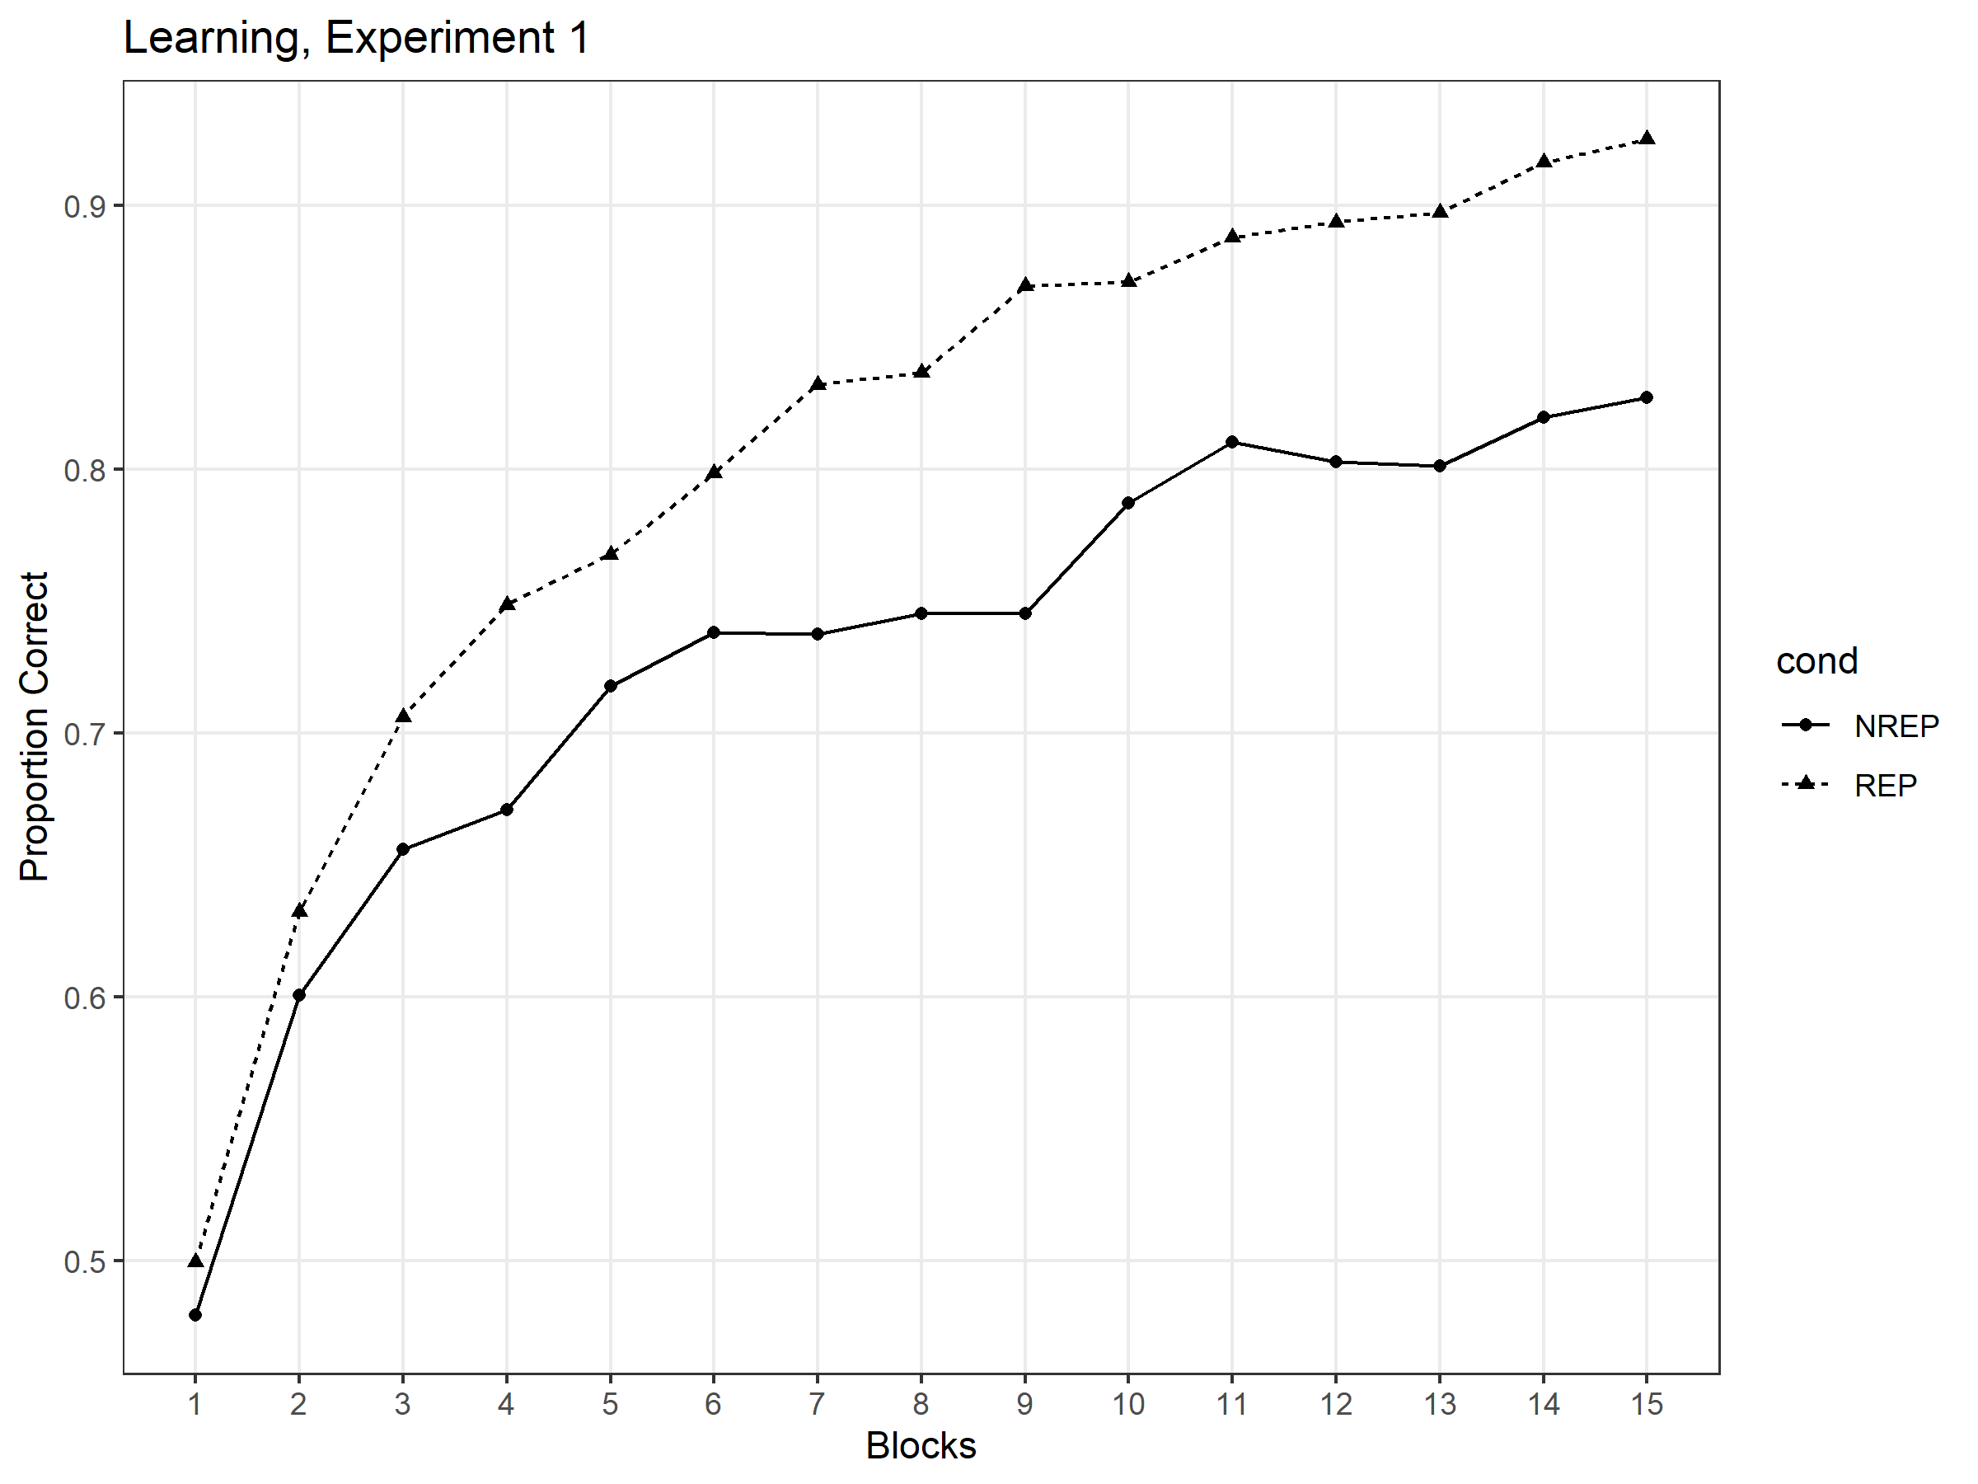

Figure 1 Mean proportion of correct classifications as a function of the number of blocks for the REP and NREP conditions, Experiment 1.

Transfer-Recognition.

The probability with which each type of transfer pattern was judged as old in the REP and NREP conditions is shown in Figure 2. As expected, in the REP condition, old-recognition probability for the old medium-distortion learning patterns (M=.845) was considerably greater than for the new medium distortions (M=.343), and was also somewhat greater than old-recognition probability for the prototypes (M=.784). By contrast, in the NREP condition, old-recognition judgments were greatest for the prototypes (M=.916). Interestingly, however, even in the NREP condition, old-recognition probability was greater for the old medium-distortion learning patterns (M=.693) than for the new medium distortions (M=.632). Recognition probabilities for the foils were by far the lowest in both the REP (M=.053) and NREP (M=.151) conditions.

To confirm these observations, we conducted a 2x4 mixed-model ANOVA, using condition (REP vs. NREP) and item type (old, new-medium, prototype, foil) as factors. The analysis revealed a significant main effect of item type, F(2.67,490.68) = 883.93, p < .001, MSe = 23.835; a significant main effect of learning condition, F(1,184) = 54.85, p < .001, MSe = 1.565; and a significant interaction between the two factors, F(2.67,490.68) = 64.66, p < .001, MSe = 1.744. In the REP condition, the old-recognition probability for the old distortions was significantly greater than for the new medium distortions, t(90) = 24.51, p <.001, Cohen’s d = 2.569; and the increased recognition probability for the old distortions compared to the prototype was marginally significant, t(90) = 2.21, p = .059\*. Although the difference was much smaller than in the REP condition, even in the NREP condition the old distortions were judged as old significantly more often than the new medium distortions, t(94) = 3.59, p = .001, Cohen’s d = .368. However, in the NREP condition, the prototypes were judged as old with significantly greater probability than were the old distortions, t(94) = 10.21, p < .001.

\*In this paper, p values of multiple t tests conducted on the same data set were adjusted for Bonferroni correction. If any p value is less than .05 before the correction but greater than .05 after the correction, we refer to the effect as “marginally significant”.

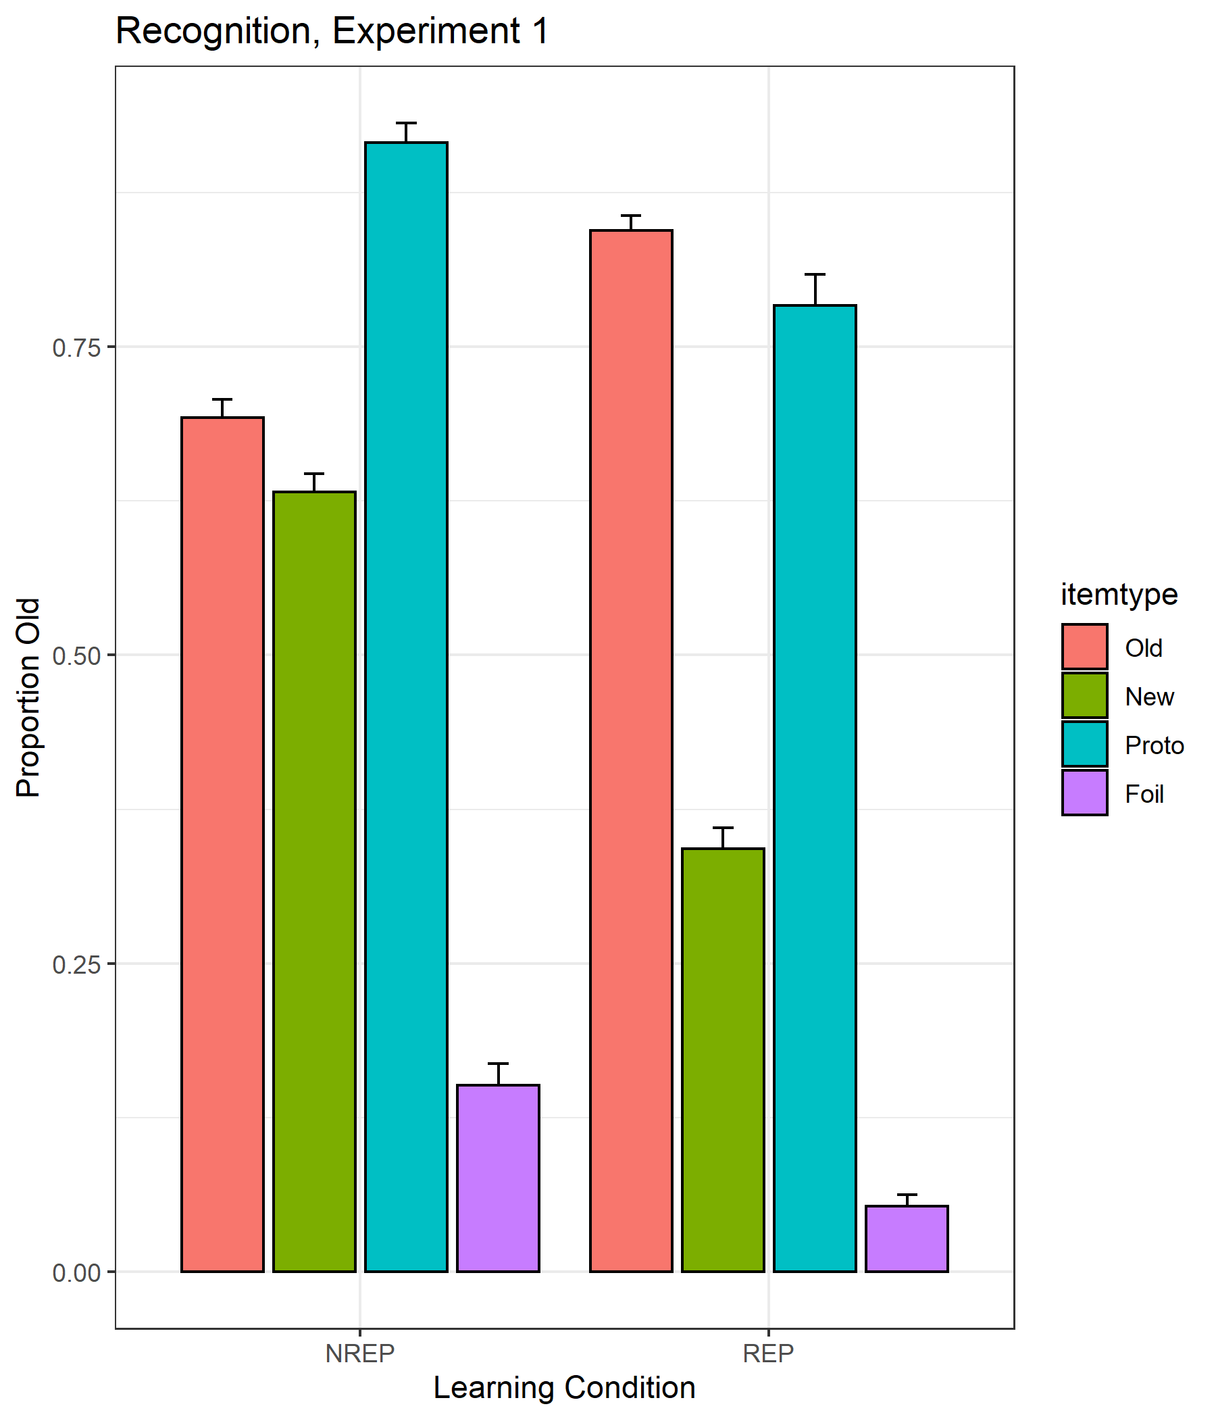

Figure 2 Mean proportion of old responses (with standard error bars) for the four different types of transfer patterns (old, new medium, prototype, foil) for REP and NREP conditions in Experiment 1.

Experiment 2

Method

Subjects

The subjects were 89 undergraduates from Indiana University who participated in partial fulfillment of an introductory psychology course requirement. There were 43 subjects in the REP condition and 46 subjects in the NREP condition. Subjects were randomly assigned to the conditions. All subjects had normal or corrected-to-normal vision.

Stimuli and Apparatus

The apparatus and method for creating the stimuli were the same as in Experiment 1.

Procedure

The procedure for the learning phase for the REP and NREP conditions was the same as described in Experiment 1.

In the transfer phase, the subjects were instructed to continue to classify the patterns into the same three categories as in the learning phase. In both the REP and NREP conditions, the set of transfer patterns was composed of 15 old distortions (5 per category), 3 prototypes (1 per category), 15 low-level distortions (5 per category), 15 new medium-level distortions (5 per category), and 15 high-level distortions (5 per category). The same procedures for choosing the old distortions in both the REP and NREP conditions were used as in Experiment 1. Each individual pattern was presented once for a total of 63 transfer trials. The order of presentation was randomized for each subject.

Results

We started by conducting preliminary analyses to remove severe outlier subjects. The measure of learning-phase performance was the same as in Experiment 1. For the classification-transfer phase, we measured average accuracy computed across all 69 transfer trials. We again deleted the data of any subject who performed more than 2.5 standard deviations below the mean in each condition on either measure. We deleted 4 subjects from the REP condition (leaving 39 valid subjects) and 2 subjects from the NREP condition (leaving 44 valid subjects). None of our main conclusions changes if all subjects are included in the analyses.

Learning

The results from the learning phase of Experiment 2 are displayed in Figure 3. The pattern of results is extremely similar to the one in Experiment 1 and provides a close replication of the earlier findings. Most important, learning performance in the REP condition was again clearly better than in the NREP condition.

We again conducted a 2x15 mixed-model ANOVA using conditions (REP vs. NREP) and blocks as factors. 4.356; as wasthe main effect of blocks, F(7.14,578.08) = 56.78 , MSe = 1.643, p < .001, η2 = .412. The interaction between the two factors was not significant in this experiment, [F(7.14,578.08) = 1.69 , MSe = .049, p = .107], most likely because the improved performance in the REP condition compared to the NREP condition occurred even more rapidly in Experiment 2 than in Experiment 1.

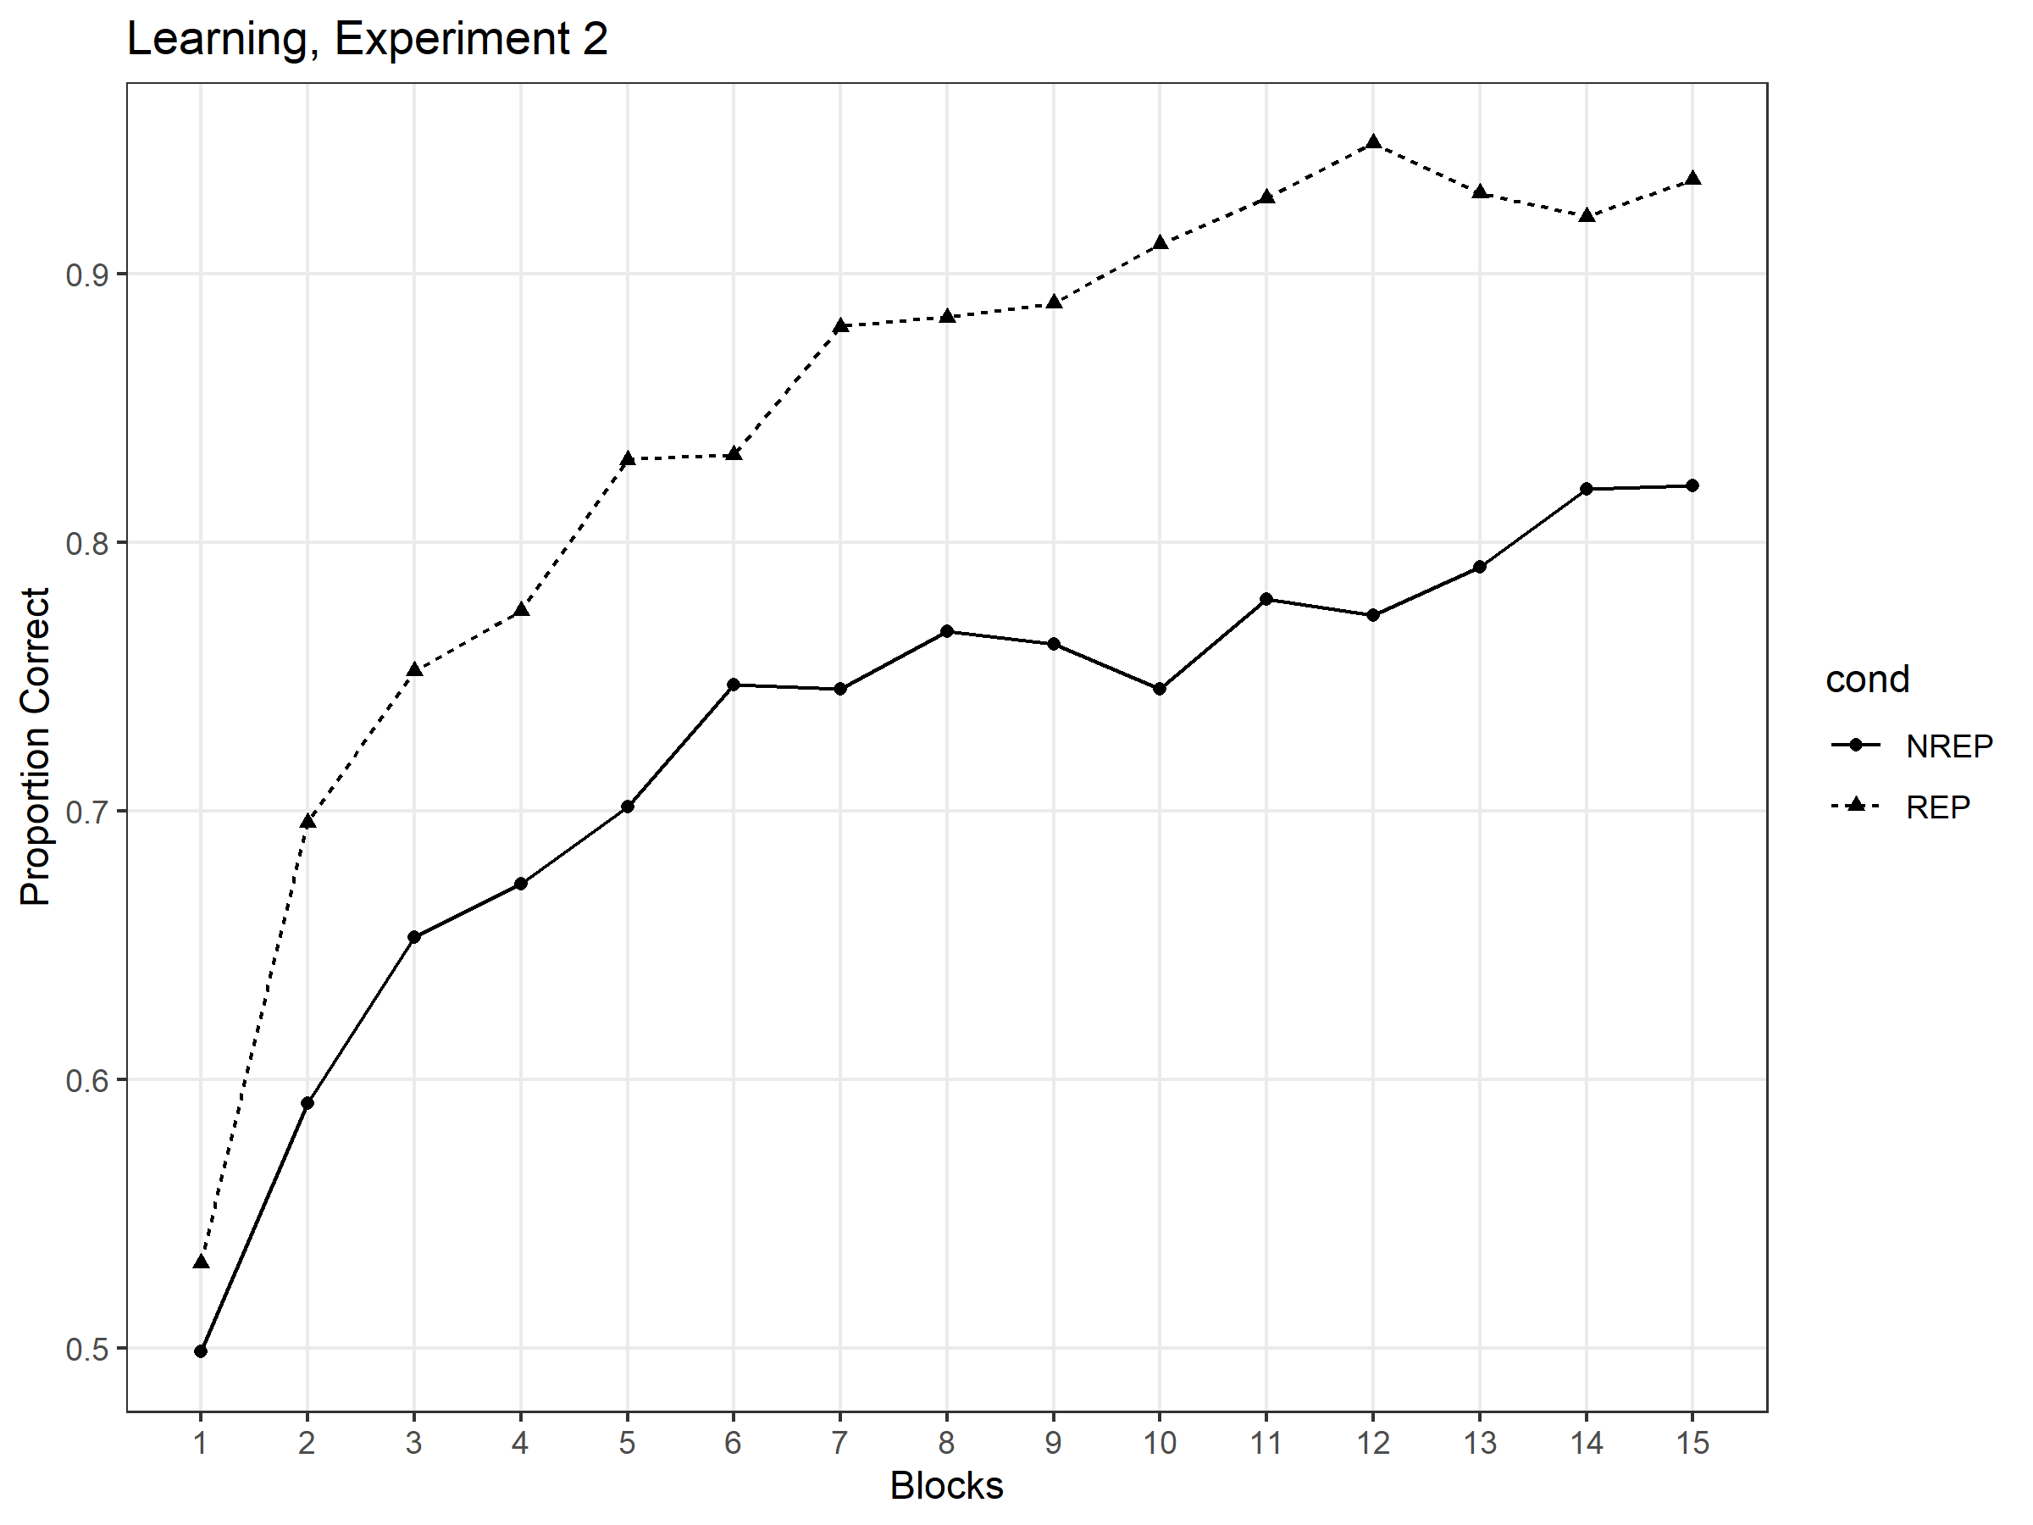

Figure 3 Mean proportion of correct classifications as a function of blocks for the REP and NREP conditions in Experiment 2

Transfer– Classification.

To facilitate the presentation, we display the classification-transfer results in two partially overlapping figures: In Figure 4 we display the probability with which the different types of *new* transfer patterns (prototype, low distortions, new medium distortions, high distortions) were correctly classified during the transfer phase in the REP and NREP conditions. This figure places focus on the typicality gradient observed for the new transfer patterns. In Figure 5, we display the probability with which the old distortions, new medium distortions, and prototypes were correctly classified during the transfer phase in the REP and NREP conditions. This figure places focus on performance comparisons between the old distortions and two of the key new transfer patterns.

As can be seen in Figure 4, we observed the classic “typicality gradient” in both the REP and NREP conditions, with classification accuracy being highest for the prototypes, followed in order by the low distortions, new medium distortions, and high distortions. We analyzed these data using a 2 x 4 mixed-model ANOVA, with learning condition (REP and NREP) as a between-subject factor and item type (prototype, low, new medium and high distortions) as a within-subject factor. The analysis yielded a main effect of item type [F(2.3,186.67) = 46.08, MSe = .696, p < .001, η2 = .363], confirming our observation of the classic typicality gradient. However, there was no main effect of learning condition [F(1,81) = .494, MSe = .030, p = .484]. Nor was the interaction between learning condition and item type statistically significant [F(2.3,186.67) = .393, MSe = .006, p = .705].

As can be seen in Figure 5, in the REP condition, the old-medium distortions were classified with higher accuracy than were the new-medium distortions; and were classified with roughly the same accuracy as the prototypes. By contrast, in the NREP condition, the prototypes were classified with the highest accuracy, and there was little if any difference in performance accuracy between the old- and new-medium distortions. To analyze these data, we conducted a 2 x 3 mixed-model ANOVA using as factors learning condition (REP, NREP) and item type (old, new-medium, prototype). The main effect of item type was significant [F(1.62,131.04) = 13.61, MSe = .183, p < .001], reflecting the generally higher performance on the prototypes and old distortions compared to the new medium distortions. There was also a significant condition x item-type interaction [F(1.62,131.04) = 4.72, MSe = .064, p = .016], reflecting the changed accuracy levels of the old distortions compared to the other patterns across the REP and NREP conditions. The main effect of condition was not significant, F(1,81) = 1.82, MSe = .085, p = .181. Subsequent paired-comparison tests showed that the old distortions were classified significantly more accurately than the new medium distortions in the REP condition, t(38) = 5.50, p < .001; although this trend continued to be observed in the NREP condition, the difference was not statistically significant, t(43) = 1.00, p = .646. In addition, the prototypes were classified significantly more accurately than were the old distortions in the NREP condition, t(43) = -2.78, p = .016. That trend was reversed in the REP condition, but the differences in the NREP condition was not statistically significant, t(38) = .98, p = .670.

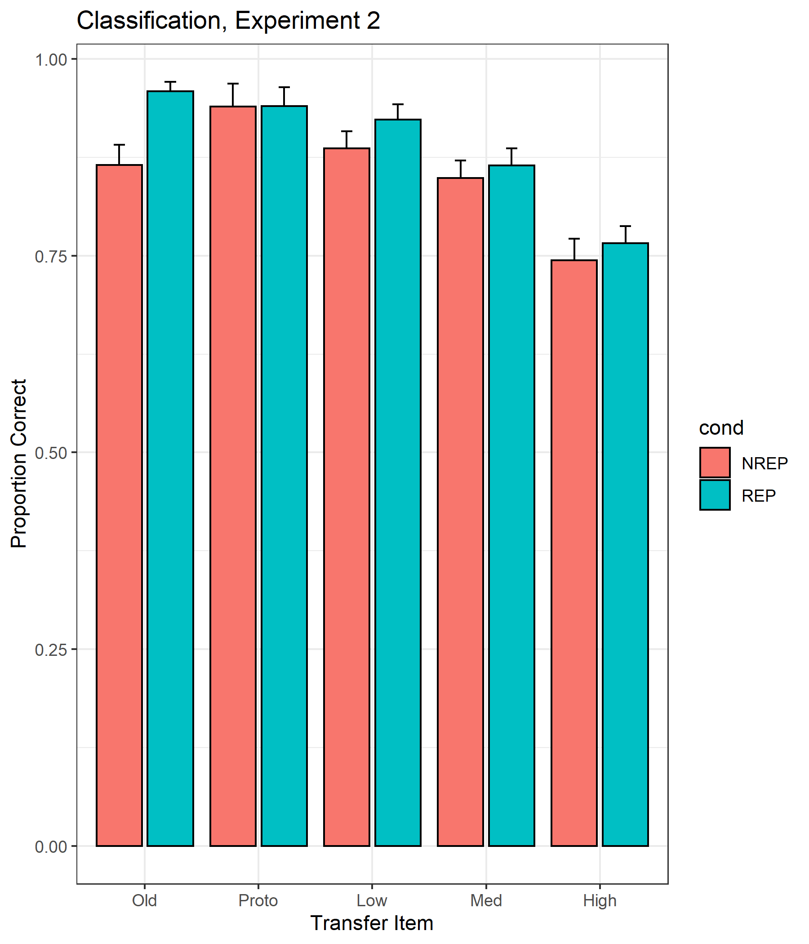

Figure 4 Mean proportion of correct classifications (with standard error bars) to five different types of transfer patterns (old medium distortion, prototype, low distortion, new medium distortion, high distortion) for REP and NREP conditions, Experiment 2.